EXERCISE-25

25.Design DFA using simulator to accept the string start with a or b over the set {a,b}

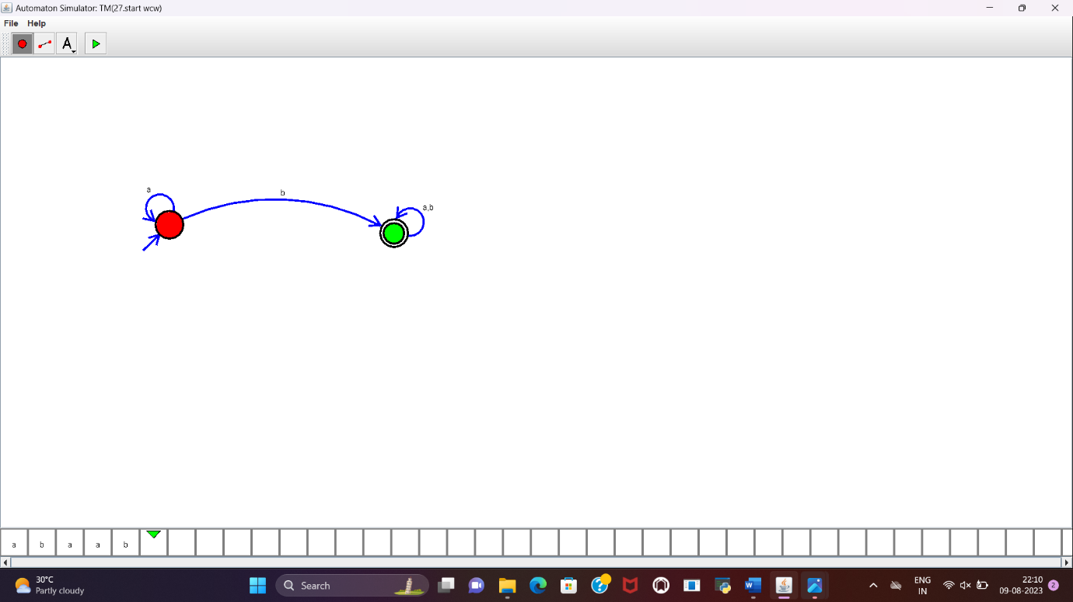

RESULT:

DFA to accept the string that start with a or b over set {a,b} is designed and implemented successfully.